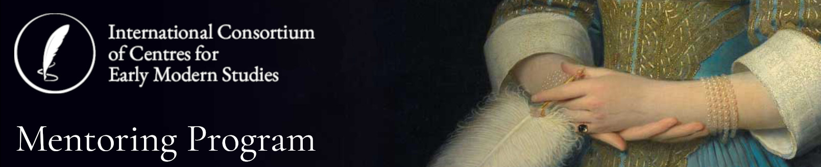

**Mentor Application Form**

Fill out and send to: [admin.iccems@anu.edu.au](mailto:admin.iccems@anu.edu.au)

|  |  |
| --- | --- |
| **Name** |  |
| **Email address** |  |
| **ICCEMS Partner Organisation** | * ANU Centre for Early Modern Studies * Centre for Reformation and Renaissance Studies (CRRS) at Victoria University-University of Toronto * Early Modern World at Harvard * Fédération Internationale des Sociétés et Instituts pour l’Étude de la Renaissance * Folger Institute, Folger Shakespeare Library * Irish Renaissance Seminar * London Renaissance Seminar * Oxford Centre for Early Modern Studies * Paris Early Modern Seminar * University of Wisconsin-Madison Center for Early Modern Studies * Independent ICCEMS Affiliate |
| **What are your main goals for establishing a mentoring relationship?** |  |
| **What area would you like to mentor in?** | * General career progression and advice |
| * Teaching and Learning |
| * Research |
| * Other (please list): |
| **How many mentees are you willing to mentor at any stage?** |  |
| **Signature** |  |
| **Date** |  |